**Bones of Head**

**The ethmoid bone**

**Contents**

* [1 Anatomical Structure](http://teachmeanatomy.info/head/osteology/ethmoid-bone/#Anatomical_Structure)
* [2 Articulations](http://teachmeanatomy.info/head/osteology/ethmoid-bone/#Articulations)

The **ethmoid bone** is a small-unpaired bone, located in the midline of the anterior cranium – the superior aspect of the skull that encloses and protects the brain.

The term ‘ethmoid’ originates from the Greek ‘*ethmos’,* meaning sieve. This is reflects in its lightweight, **spongy** structure.

**Anatomical Structure**

The ethmoid bone is one of the eight bones of the cranium. It is situate at the roof of the [**nasal cavity**](http://teachmeanatomy.info/head/organs/the-nose/nasal-cavity/), and between the two orbital cavities.

It contributes to the medial wall of the [orbit](http://teachmeanatomy.info/head/organs/eye/bony-orbit/)and forms part of the [**anterior cranial fossa**](http://teachmeanatomy.info/head/areas/cranial-fossa/anterior/), where it separates the [nasal cavity](http://teachmeanatomy.info/head/organs/the-nose/nasal-cavity/) (inferiorly) from the cranial cavity (superiorly). It also forms a significant portion of the nasal septum and lateral nasal wall.

The [**olfactory nerve**](http://teachmeanatomy.info/head/cranial-nerves/olfactory-cni/) (CN I) has a close anatomical relationship with the ethmoid bone. Its numerous nerve fibers pass through the cribriform plate of the ethmoid bone to innervate the [nasal cavity](http://teachmeanatomy.info/head/organs/the-nose/nasal-cavity/) with the sense of smell.

[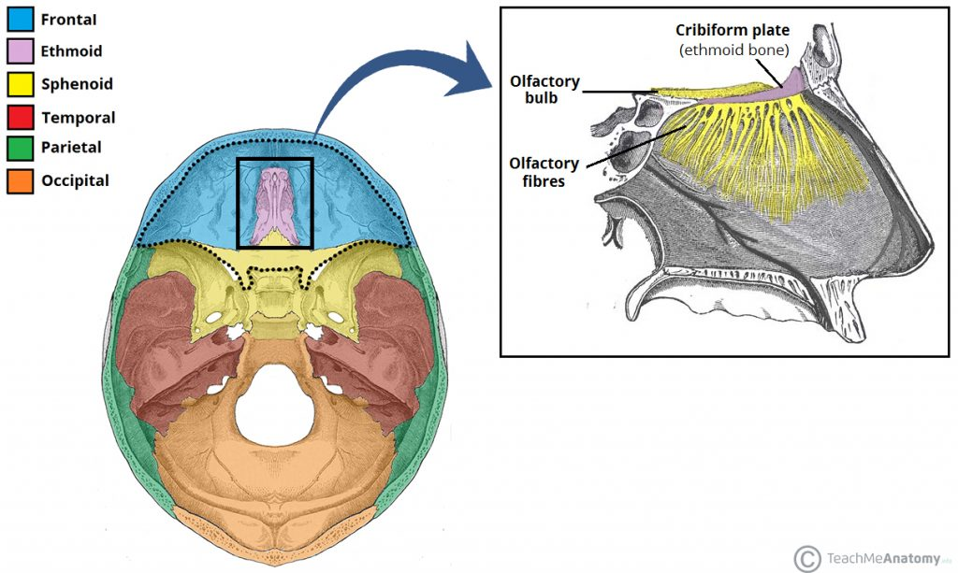](https://cdn1.teachmeseries.com/tmanatomy/wp-content/uploads/20171222220420/Anatomical-Location-and-Relations-of-the-Ethmoid-Bone-1024x613.jpg)

Fig 1 – The anatomical position and relations of the ethmoid bone.

The ethmoid bone made up of three parts – the cribriform plate, the perpendicular plate and the ethmoidal labyrinth.

The **cribriform plate** forms the roof of the nasal cavity. Numerous olfactory nerve fibers pierce it, which gives it a sieve-like structure. Projecting superiorly from the cribriform plate is the crista galli, which provides an attachment point for the falx cerebri (sheet of dura mater that separates the two cerebral hemispheres).

Another projection of bone descends from the cribriform plate – the **perpendicular plate**. It forms the superior two-thirds of the nasal septum.

Lastly, the ethmoid bone contains two **ethmoidal labyrinths**. These are large masses located at either side of the perpendicular plate, which contain the [ethmoidal air cells (sinuses)](http://teachmeanatomy.info/head/organs/the-nose/paranasal-sinuses/). Two sheets of bone form each labyrinth:

* **Orbital plate** – the lateral sheet of bone, which also forms the medial wall of the [orbit](http://teachmeanatomy.info/head/organs/eye/bony-orbit/)
* **Medial sheet** – forms the upper lateral wall of the [nasal cavity](http://teachmeanatomy.info/head/organs/the-nose/nasal-cavity/), from which the superior and middle conchae extend into the nasal cavity.

[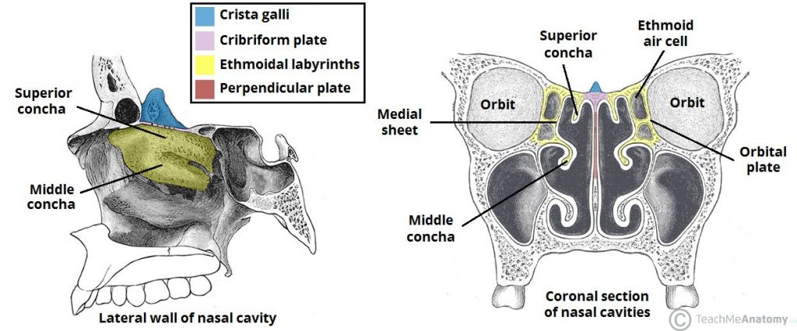](https://cdn1.teachmeseries.com/tmanatomy/wp-content/uploads/20171222220436/Ethmoid-Bone-and-Sinuses-in-the-Nasal-Cavity.-1024x426.jpg)

Fig 2 – The ethmoid bone within the nasal cavity.

**Articulations**

The ethmoid bone articulates with 13 others:

* **Paired** – nasal bones, maxillae, lacrimal bones, palatine bones, inferior conchae.
* **Unpaired** – frontal, vomer and [sphenoid](http://teachmeanatomy.info/head/osteology/sphenoid-bone/) bones.

**The mandible**

**Contents**

* [1 Anatomical Structure](http://teachmeanatomy.info/head/osteology/mandible/#Anatomical_Structure)
  + [1.1 Body](http://teachmeanatomy.info/head/osteology/mandible/#Body)
  + [1.2 Rami](http://teachmeanatomy.info/head/osteology/mandible/#Rami)
  + [1.3 Foramina](http://teachmeanatomy.info/head/osteology/mandible/#Foramina)
* [2 Muscular Attachments](http://teachmeanatomy.info/head/osteology/mandible/#Muscular_Attachments)
* [3 Articulations](http://teachmeanatomy.info/head/osteology/mandible/#Articulations)

The **mandible**, located inferiorly in the facial skeleton, is the largest and strongest bone of the face.

It forms the lower jaw and acts as a receptacle for the lower teeth. It also articulates on either side with the temporal bone, forming the **temporomandibular joint**.

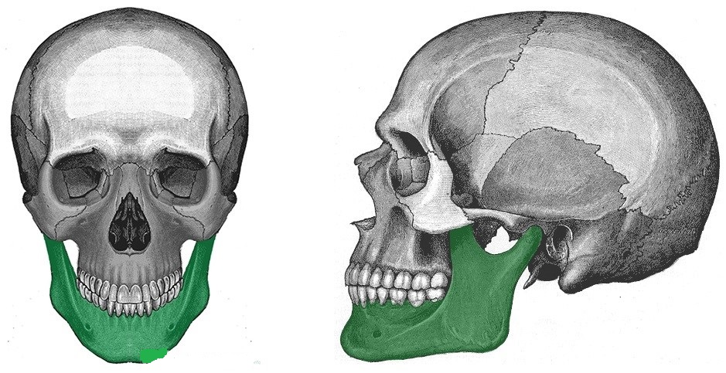

Fig 3 – Anterior and lateral views of the mandible within the facial skeleton.

**Anatomical Structure**

The mandible consists of a horizontal **body** (anteriorly) and two vertical **rami** (posteriorly). The body and the rami meet on each side at the angle of the mandible.

**Body**

The body of the mandible curved, and shaped much like a horseshoe. It has two borders:

* **Alveolar border (superior)**– contains 16 sockets to hold the lower teeth.
* **Base** **(inferior)**– site of attachment for the digastric muscle medially

The body is marked in the midline by the **mandibular symphysis** (a small ridge of bone that represents the fusion of the two halves during development). The symphysis encloses a triangular eminence – the mental protuberance, which forms the shape of the chin.

Lateral to the mental protuberance is the **mental foramen**(below the second premolar tooth on either side). It acts as a passageway for neurovascular structures.

**Rami**

There are two **mandibular rami**, which project perpendicularly upwards from the angle of the mandible. Each ramus contains the following bony landmarks:

* **Head** – situated posteriorly, articulates with the [temporal](http://teachmeanatomy.info/head/osteology/temporal-bone/) bone to form the [temporomandibular](http://teachmeanatomy.info/head/joints/temporomandibular/) joint.
* **Neck** – supports the head of the ramus, and site of attachment of the lateral pterygoid muscle.
* **Coronoid process** – site of attachment of the temporalis muscle

The internal surface of the ramus also marked by the **mandibular foramen**, which acts as a passageway for neurovascular structures.

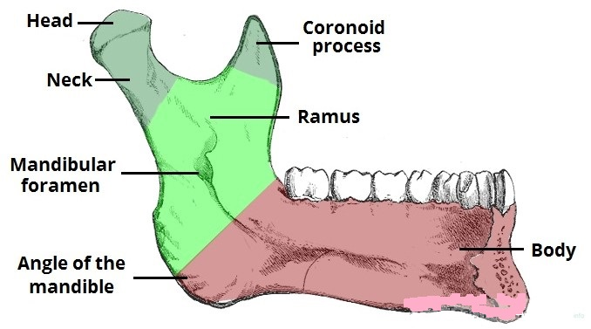

Fig 4 – Internal surface of the mandible and its bony landmarks.

**Foramina**

A foramen refers to any opening through which neurovascular structures can travel. The mandible is marked by two foramina.

The**mandibular foramen** is located on the internal surface of the ramus of the mandible. It serves as a conduit for the inferior alveolar nerve and inferior alveolar artery. They travel through the mandibular foramen, into the mandibular canal, and exit at the mental foramen.

The**mental foramen**, positioned on the external surface of the mandibular body, below the second premolar tooth. It allows the inferior alveolar nerve and artery to exit the mandibular canal. When the inferior alveolar nerve passes through the mental foramen, it becomes the mental nerve (innervates the skin of the lower lip and the front of the chin).

**Muscular Attachments**

The mandible serves as the attachment point for the various muscles, including the strong [muscles of mastication](http://teachmeanatomy.info/head/muscles/mastication/).

* **Mandibular body:**
  + External (lateral) surface – mentalis, buccinator, platysma, depressor labii inferioris, depressor anguli oris.
  + Internal (medial) surface – genioglossus, geniohyoid, mylohyoid and digastric.
* **Mandibular rami** – masseter, temporalis, medial pterygoid and lateral pterygoid.

The temporalis muscle attaches to the **coronoid process**, and the masseter attaches to the rami. The lateral pterygoid inserts into the neck of the mandible, and the medial pterygoid inserts into the ramus near the angle of the mandible.

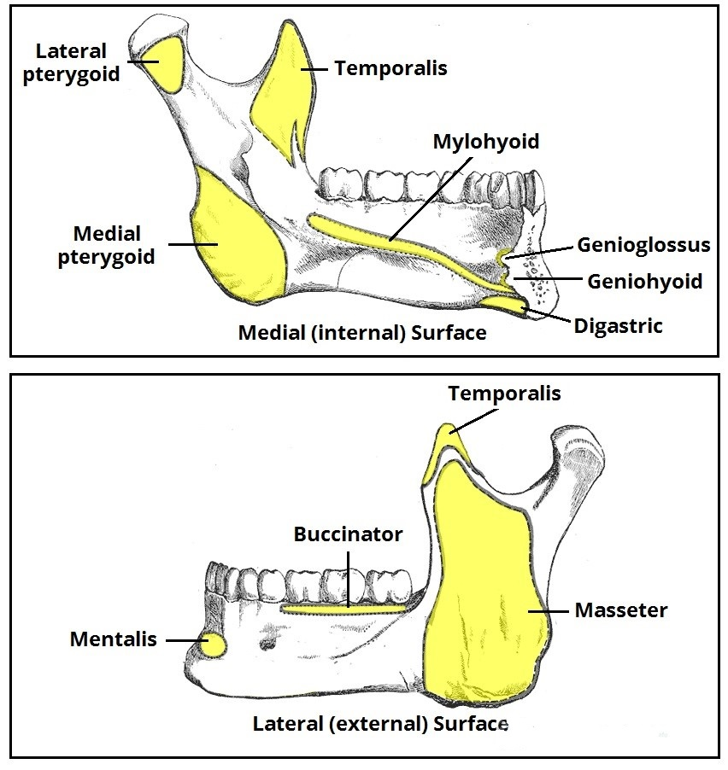

Fig 5 – Muscular attachments to the mandible.

**Articulations**

The mandible articulates with the [temporal](http://teachmeanatomy.info/head/osteology/temporal-bone/) bone to form the [temporomandibular](http://teachmeanatomy.info/head/joints/temporomandibular/) joint which discussed in more detail [here](http://teachmeanatomy.info/head/joints/temporomandibular/).

**The** **sphenoid bone**

**Contents**

* [1 Anatomical Structure](http://teachmeanatomy.info/head/osteology/sphenoid-bone/#Anatomical_Structure)
  + [1.1 Body](http://teachmeanatomy.info/head/osteology/sphenoid-bone/#Body)
  + [1.2 Greater Wing](http://teachmeanatomy.info/head/osteology/sphenoid-bone/#Greater_Wing)
  + [1.3 Lesser Wing](http://teachmeanatomy.info/head/osteology/sphenoid-bone/#Lesser_Wing)
  + [1.4 Pterygoid Process](http://teachmeanatomy.info/head/osteology/sphenoid-bone/#Pterygoid_Process)
* [2 Muscular Attachments](http://teachmeanatomy.info/head/osteology/sphenoid-bone/#Muscular_Attachments)
* [3 Articulations](http://teachmeanatomy.info/head/osteology/sphenoid-bone/#Articulations)

The **sphenoid bone** is one of the eight bones that make up the cranium – the superior aspect of the skull that encloses and protects the brain.

Its name derived from the Greek *‘sphenoeides’,* to mean wedge-shaped.

[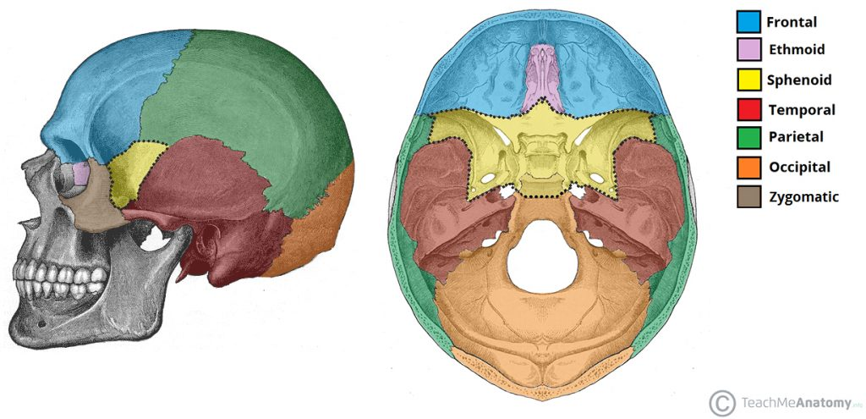](https://cdn1.teachmeseries.com/tmanatomy/wp-content/uploads/20171222220415/Position-of-the-Sphenoid-Bone-in-the-Skull.-1024x495.jpg)

Fig 6 – The position of the sphenoid bone (yellow) within the facial skeleton.

**Anatomical Structure**

The sphenoid bone is said to be ‘**butterfly-shaped**‘. It consists of a body, paired greater wings and lesser wings, and two pterygoid processes.

**Body**

The body lies at the center of the sphenoid bone, and is almost completely cubical in shape.

It contains the **sphenoidal sinuses**, which separated by a septum – meaning that the sphenoid body is essentially hollow. The body articulates with the ethmoid bone anteriorly, and it is here that the sinuses open up into the nasal cavity.

The superior surface of the sphenoid body contains some important bony landmarks:

* **Sella turcica** – a saddle-shaped depression. It has three parts:
  + *Tuberculum sellae* – forms the anterior wall of the sella turcica, and the posterior aspect of the chiasmatic groove.
  + *Hypophyseal fossa* – the deepest part of the sella turcica, where the pituitary gland is located.
  + *Dorsum sellae* – forms the posterior wall of the sella turcica.
* **Chiasmatic groove** – a sulcus formed by the optic chiasm (where the optic nerves partially cross).

The anterior and posterior clinoid processes surround the sella turcica. The anterior clinoid processes arise from the sphenoidal lesser wings, while the posterior clinoid processes are the superolateral projections of the dorsum sellae. They serve as attachment points for the **tentorium cerebelli**, a membranous sheet that divides the brain.

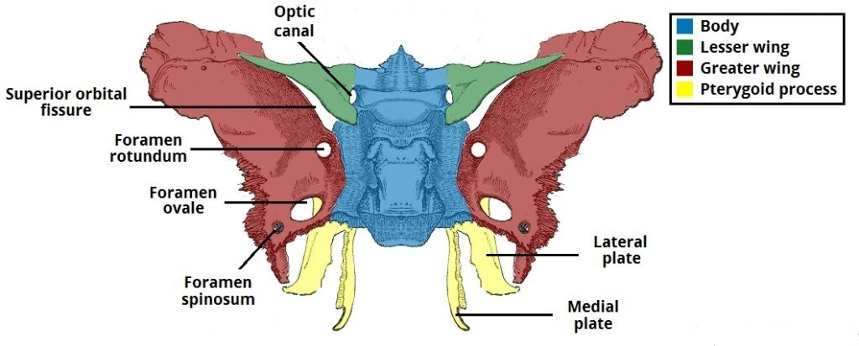

Fig 7 – Foramina and bony landmarks of the sphenoid wings and pterygoid process.

[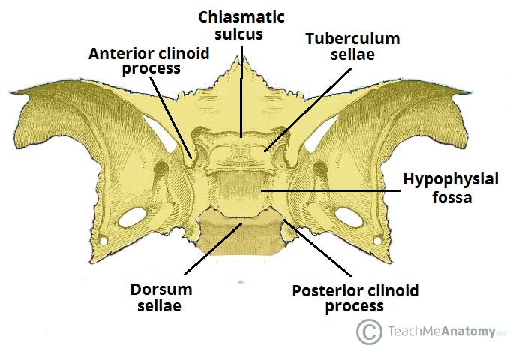](https://cdn1.teachmeseries.com/tmanatomy/wp-content/uploads/20171222215252/Bony-Landmarks-of-the-Sphenoid-Body-in-the-Middle-Cranial-Fossa.jpg)

Fig 8 – Bony landmarks of the sphenoid body.

**Greater Wing**

The **greater wing** extends from the sphenoid body in a lateral, superior and posterior direction. It contributes to three parts of the facial skeleton:

* Floor of the middle cranial fossa
* Lateral wall of the skull
* Posterolateral wall of the orbit

There are three **foramina** present in the greater wing– the foramen rotundum, foramen ovale and foramen spinosum. They conduct the maxillary nerve, mandibular nerve and middle meningeal vessels respectively.

**Lesser Wing**

The **lesser wing** arises from the anterior aspect of the sphenoid body in a superolateral direction. It separates the anterior cranial fossa from the middle cranial fossa.

It also forms the lateral border of the **optic canal** – through which the optic nerve and ophthalmic artery travel to reach the eye. The body of the sphenoid forms the medial border of the optic canal.

There is a ‘slit-like’ gap between the lesser and greater wings of the sphenoid – the **superior orbital fissure**. Numerous structures pass through here to reach the bony orbit.

**Pterygoid Process**

The pterygoid process descends inferiorly from the point of junction between the sphenoid body and the greater wing. It consists of two parts:

* **Medial pterygoid plate** – supports the posterior opening of the nasal cavity.
* **Lateral pterygoid plate** – site of origin of the medial and lateral pterygoid muscles

**Muscular Attachments**

The lateral and medial pterygoid muscles, which form some of the muscles of mastication, originate from the **lateral pterygoid plate of the sphenoid bone.**

**Articulations**

The sphenoid is an **unpaired** bone. It sits anteriorly in the cranium, and contributes to the [middle cranial fossa](http://teachmeanatomy.info/head/areas/middle-cranial-fossa/), the lateral wall of the skull, and the floor and sides of both orbits.

It has articulations with twelve other bones:

* **Unpaired bones** – Occipital, vomer, ethmoid and frontal bones.
* **Paired bones** – Temporal, parietal, zygomatic and palatine bones.

**The temporal bone**

**Contents**

[1 .Anatomical Structure](http://teachmeanatomy.info/head/osteology/temporal-bone/#Anatomical_Structure)

* + [1.1 Squamous](http://teachmeanatomy.info/head/osteology/temporal-bone/#Squamous)
  + [1.2 Zygomatic Process](http://teachmeanatomy.info/head/osteology/temporal-bone/#Zygomatic_Process)
  + [1.3 Tympanic](http://teachmeanatomy.info/head/osteology/temporal-bone/#Tympanic)
  + [1.4 Styloid Process](http://teachmeanatomy.info/head/osteology/temporal-bone/#Styloid_Process)
  + [1.5 Petromastoid](http://teachmeanatomy.info/head/osteology/temporal-bone/#Petromastoid)
* [2 Muscular Attachments](http://teachmeanatomy.info/head/osteology/temporal-bone/#Muscular_Attachments)
* [3 Articulations](http://teachmeanatomy.info/head/osteology/temporal-bone/#Articulations)

The temporal bone contributes to the lower **lateral** walls of the skull. Its contain the [middle](http://teachmeanatomy.info/head/organs/ear/middle-ear/) and [inner](http://teachmeanatomy.info/head/organs/ear/inner-ear/) portions of the ear, and crossed by the majority of the**cranial nerves.**The lower portion of the bone articulates with the [**mandible**](http://teachmeanatomy.info/head/osteology/mandible/), forming the [temporomandibular joint](http://teachmeanatomy.info/head/temporomandibular-joint/) of the jaw.

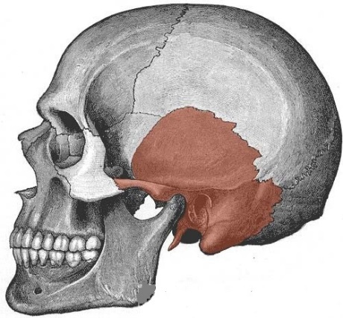

Fig 9 – Lateral view of the skull. The temporal bone has highlighted.

**Anatomical Structure**

The temporal bone itself is comprised of **five** constituent parts. The squamous, tympanic and petromastoid parts make up the majority of the bone, with the zygomatic and styloid processes projecting outwards.

[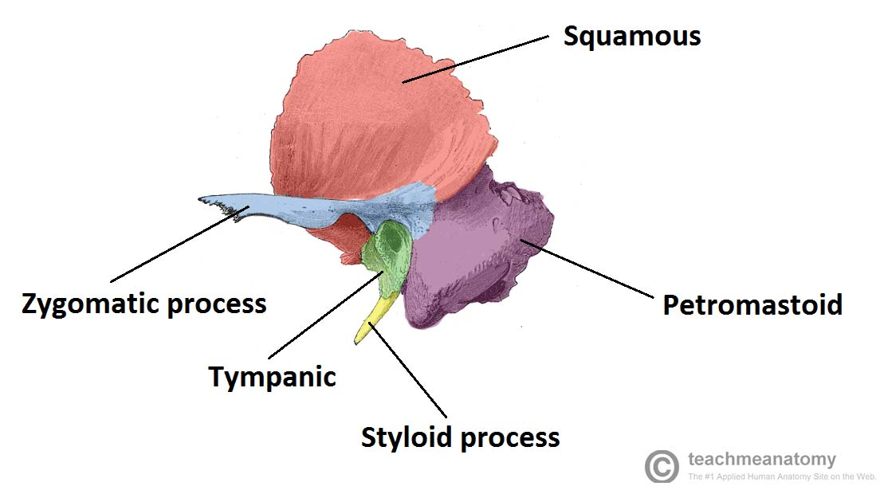](https://cdn1.teachmeseries.com/tmanatomy/wp-content/uploads/20171222214201/Diagram-of-the-Constiuent-Parts-of-the-Temporal-Bone-1024x566.jpg)

Fig 10 – The constituent parts of the temporal bone.

We shall now examine the constituent parts of the temporal bone in more detail.

**Squamous**

Also known as the squama temporalis, this is the largest part of the temporal bone. It is **flat** and plate-like, located superiorly. The outer facing surface of the squamous bone is **convex** in shape, forming part of the temporal **fossa**.

The lower part of the squamous bone is the site of origin of the **temporalis** muscle

The bone articulates with the [**sphenoid**](http://teachmeanatomy.info/head/osteology/sphenoid-bone/) bone anteriorly, and **parietal** bone laterally.

**Zygomatic Process**

The**zygomatic process** arises from the lower part of the squama temporalis. It projects anteriorly, articulating with the temporal process of the zygomatic bone. These two structures form the**zygomatic arch** (palpable as ‘cheek bones’).

One of the zygomatic processes’ attachments to the temporal bone forms the **articular tubercle**– the anterior boundary of the mandibular fossa, part of the [temporomandibular](http://teachmeanatomy.info/head/joints/temporomandibular/) joint

The **masseter** muscles attaches some fibers to the lateral surface of the zygomatic process.

**Tympanic**

The tympanic part of the temporal bone lies **inferiorly** to the squamous, and **anteriorly** to the petromastoid part. It surrounds the external auditory **opening**, which leads into the external auditory meatus of the [external ear](http://teachmeanatomy.info/anatomy-of-the-external-ear/).

**Styloid Process**

The styloid process located immediately underneath the opening to the auditory meatus. It acts as an **attachment** point for muscles and ligaments, such as the Stylomandibular ligament of the TMJ.

**Petromastoid**

This portion of the temporal bone is located **posteriorly**. It can split into mastoid and petrous parts. On a lateral view of the temporal bone, such as figure 10 above, only the **mastoid** part is visible.

There are two items of note on the mastoid. The first is the**mastoid process**, an inferior projection of bone, palpable just behind the ear. It is a site of attachment for many muscles, such as the **sternocleidomastoid**.

Also of clinical importance are the **mastoid air cells**. These **hollowed** out areas within the temporal bone. They act as a **reservoir**of air, equalizing the pressure within the [middle ear](http://teachmeanatomy.info/head/organs/ear/middle-ear/) in the case of **auditory tube** dysfunction. The mastoid air cells might be infected, known as **mastoiditis**.

The **petrous** part is pyramidal shaped, and lies at the base of temporal bone. It contains the inner ear.

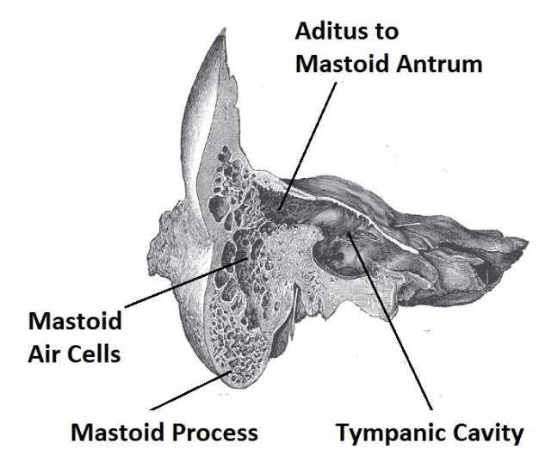

Fig 11 – Coronal section of temporal bone, showing the mastoid air cells in more detail

**Muscular Attachments**

The temporal bone serves as a point of attachment for many muscles. Due to the involvement of the temporal bone in forming the [temporomandibular joint](http://teachmeanatomy.info/head/joints/temporomandibular/) (i.e. joint of the jaw) some fibers from muscles of mastication such as the temporalis and masseter muscles attach to the temporal bone. In addition, the mastoid process of the temporal bone is a major site of muscle attachment. Some key muscular attachments outlined in the table below.

**Articulations**

A major articulation of the temporal bone is with the [mandible](http://teachmeanatomy.info/head/osteology/mandible/) (i.e. jawbone) to form the [temporomandibular joint](http://teachmeanatomy.info/head/joints/temporomandibular/) which is covered in detail [here](http://teachmeanatomy.info/head/joints/temporomandibular/).

The squamous part of the temporal bone also articulates with the [sphenoid](http://teachmeanatomy.info/head/osteology/sphenoid-bone/) bone anteriorly and the parietal bone laterally.

The zygomatic process of the temporal bone also articulates with the zygomatic bone to form the zygomatic arch (i.e. cheekbones).

|  |  |  |
| --- | --- | --- |
| **Muscle** | **Site of Attachment** | **Description** |
| Temporalis | Originates from the lower part of squamous | Muscle of mastication |
| Masseter | Lateral zygomatic surface | Muscle of mastication |
| Sternocleidomastoid | Mastoid process | Superficial muscle of the neck. Involved in rotation of head and flexion of neck. Important landmark for the [anterior](http://teachmeanatomy.info/neck/areas/anterior-triangle/) and [posterior](http://teachmeanatomy.info/neck/areas/posterior-triangle/) cervical triangles. |
| Posterior belly of digastric | Mastoid process | A [suprahyoid](http://teachmeanatomy.info/neck/muscles/suprahyoid-muscles/) muscle. Involved in processes such as swallowing. |

**The nasal skeleton**

**Contents**

[1. Anatomical Structure](http://teachmeanatomy.info/head/osteology/nasal-skeleton/#Anatomical_Structure)

* + [1.1 External Nasal Skeleton](http://teachmeanatomy.info/head/osteology/nasal-skeleton/#External_Nasal_Skeleton)
  + [1.2 Internal Nasal Septum](http://teachmeanatomy.info/head/osteology/nasal-skeleton/#Internal_Nasal_Septum)

The nasal skeleton is a combination of bone and cartilage, which forms both what we can see as the external nose and the internal nasal septum – which divides the two nasal cavities of the head.

**Anatomical Structure**

The skeleton of the nose is formed by three types of tissue; bone, cartilage and fibro-fatty tissue. When looking at the scaffolding of the nose, it is useful to divide the structures into two parts; the **external nasal skeleton** and **internal nasal septum**.

* **External Nasal Skeleton**

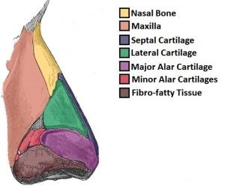

Figure 12 – Lateral view of the external nasal skeleton

The **external skeleton** extends the nasal cavities onto the front of the face. Partly formed by the **nasal** and **maxillary** bones, which situated superiorly. The inferior portion of the nose made up of hyaline cartilages; lateral, major alar, minor alar, and the cartilaginous **septum**. The lateral and major alar cartilages are the largest, and contribute the most to the shape of the nose here. The minor alar cartilages vary in number; there are usually 3 or 4 on each side.

* **Internal Nasal Septum**

The internal **nasal septum** separates the nasal cavity into two nostrils. The bones that contribute to the nasal septum divided into:

* **Paired bones**: Nasal, maxillary and palatine bones
* **Unpaired bones**: Ethmoid and vomer bones.

In addition to the bones of the nose, the septal and greater alar cartilages also constitute part of the nasal septum.

The [**ethmoid**](http://teachmeanatomy.info/head/osteology/ethmoid-bone/) contributes to the central portion of nasal septum. It is one of the most complex bones in the human body. The anterior and posterior parts formed by the**septal cartilage** and **vomer** bone respectively.

The **floor** of the nasal cavity formed by the hard palate, separating it from the [oral cavity](http://teachmeanatomy.info/head/organs/oral-cavity/). The **hard palate** consists of the **palatine bone** posteriorly, and the palatine process of the **maxilla** anteriorly. The cribriform plate of the [ethmoid bone](http://teachmeanatomy.info/head/osteology/ethmoid-bone/) forms the posterior roof.

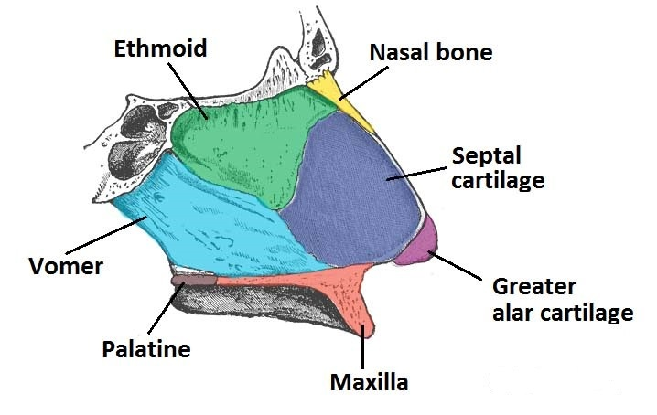

Figure 13 – Lateral view of the side of the nasal septum.

**Cranial foramina**

**Contents**

* [1 Cranial Nerve Foramina](http://teachmeanatomy.info/head/osteology/cranial-foramina/#Cranial_Nerve_Foramina)
  + [1.1 Cribriform Foramina](http://teachmeanatomy.info/head/osteology/cranial-foramina/#Cribriform_Foramina)
  + [1.2 Optic Canal and Foramen](http://teachmeanatomy.info/head/osteology/cranial-foramina/#Optic_Canal_and_Foramen)
  + [1.3 Superior Orbital Fissure](http://teachmeanatomy.info/head/osteology/cranial-foramina/#Superior_Orbital_Fissure)
  + [1.4 Foramen Rotundum](http://teachmeanatomy.info/head/osteology/cranial-foramina/#Foramen_Rotundum)
  + [1.5 Foramen Ovale](http://teachmeanatomy.info/head/osteology/cranial-foramina/#Foramen_Ovale)
  + [1.6 Internal Acoustic Meatus](http://teachmeanatomy.info/head/osteology/cranial-foramina/#Internal_Acoustic_Meatus)
  + [1.7 Jugular Foramen](http://teachmeanatomy.info/head/osteology/cranial-foramina/#Jugular_Foramen)
  + [1.8 Hypoglossal Canal – CN XII](http://teachmeanatomy.info/head/osteology/cranial-foramina/#Hypoglossal_Canal_CN_XII)
* [2 Other Foramina](http://teachmeanatomy.info/head/osteology/cranial-foramina/#Other_Foramina)
  + [2.1 Foramen Magnum](http://teachmeanatomy.info/head/osteology/cranial-foramina/#Foramen_Magnum)
  + [2.2 Foramen Spinosum](http://teachmeanatomy.info/head/osteology/cranial-foramina/#Foramen_Spinosum)
* [3 Summary](http://teachmeanatomy.info/head/osteology/cranial-foramina/#Summary)

A **foramen** (pl. foramina) is an opening that allows the passage of structures from one region to another.

In the skull base, there numerous foramina that transmit cranial nerves, blood vessels and other structures – these collectively referred to as the **cranial foramina**.

**Cranial Nerve Foramina**

We will discuss the foramina that transmit cranial nerves.

[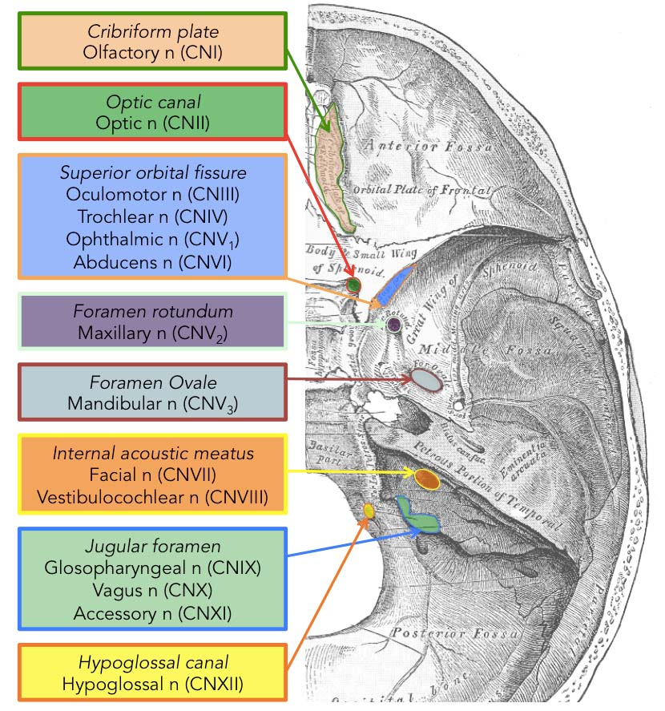](https://cdn1.teachmeseries.com/tmanatomy/wp-content/uploads/20171222220133/CN-base-of-skull.jpg)

Figure 14 – Superior view of the skull base showing the foramina and the cranial nerves that pass through them.

**Cribriform Foramina**

The cribriform foramina refer to numerous perforations in the **cribriform plate** of the [**ethmoid bone**](http://teachmeanatomy.info/head/osteology/ethmoid-bone/). They connect the **anterior cranial fossa** with the **nasal cavity**.

These foramina allow the passage of axons of the olfactory nerve from the olfactory epithelium of the nose into the anterior cranial fossa where they communicate with the **olfactory bulb**.

**Optic Canal and Foramen**

The **optic canal** permits the passage of the optic nerve (CN II) and the ophthalmic artery into the bony orbit.

Bounded medially by the body of the sphenoid, and laterally by the **lesser wing** of the [sphenoid bone](http://teachmeanatomy.info/head/osteology/sphenoid-bone/)

**Superior Orbital Fissure**

The**superior orbital fissure** is a cleft that opens anteriorly into the orbit, and enables communication between the cavernous sinus and the apex of the [orbit](http://teachmeanatomy.info/head/organs/eye/bony-orbit/)

Bordered superiorly by the lesser wing and inferiorly by the greater wing of the **sphenoid bone**.

It transmits several structures that listed below (from superior to inferior):

* Lacrimal nerve
* Frontal nerve – branch of ophthalmic nerve of trigeminal nerve (CN V)
* Superior ophthalmic vein
* Trochlear nerve (CN IV)
* Superior division of the Oculomotor nerve (CN III)
* Nasociliary nerve – branch of ophthalmic nerve of trigeminal nerve (CN V)
* Inferior division of the Oculomotor nerve (CN III)
* Abducens nerve (CN VI)
* A branch of the Inferior ophthalmic vein



Fig 15 – Foramina and bony landmarks of the sphenoid wings and pterygoid process.

**Foramen Rotundum**

The **foramen rotundum** is located at the base of the greater wing of the sphenoid, inferior to the superior orbital fissure.

It provides a connection between the middle cranial fossa and the [pterygopalatine fossa](http://teachmeanatomy.info/head/areas/pterygopalatine-fossa/). The **maxillary nerve** (branch of the trigeminal nerve, CN V) passes through this foramen.

**Foramen Ovale**

The foramen ovale is another opening located at the base of the greater wing of the sphenoid.

It is positioned posterolaterally to the foramen rotundum within the middle cranial fossa. It conducts the **mandibular nerve**(branch of the trigeminal nerve, CN V) and the accessory meningeal artery.

**Internal Acoustic Meatus**

The **internal acoustic meatus** is a bony passage located within the petrous part of the [temporal bone](http://teachmeanatomy.info/head/osteology/temporal-bone/).

The canal connects the [posterior cranial fossa](http://teachmeanatomy.info/head/areas/cranial-fossa/posterior/) and the inner ear, transporting neurovascular structures to the auditory and vestibular apparatus. The **facial** and **vestibulocochlear** nerves pass through the internal acoustic meatus, alongside the vestibular ganglion and labyrinthine artery.

**Jugular Foramen**

The **jugular foramen** formed anteriorly by the petrous part of the temporal bone and posteriorly by the occipital bone.

It considered as three separate compartments with their respective contents:

* **Anterior** – contains the inferior petrosal sinus (a Dural venous sinus).
* **Middle** – transmits the glossopharyngeal nerve, vagus nerve and cranial part of the accessory nerve.
* **Posterior** – contains the sigmoid sinus, and transmits meningeal branches of occipital and ascending pharyngeal arteries.

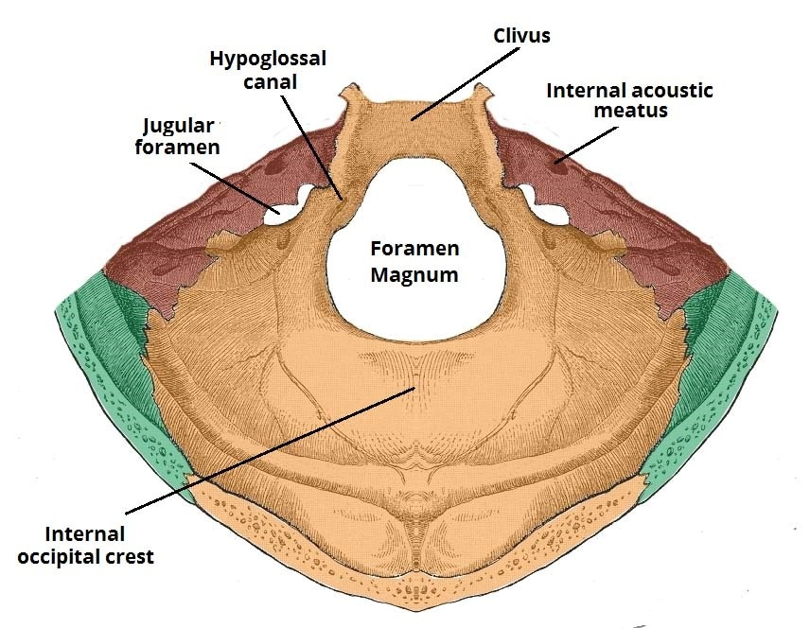

Fig 16 – The bony landmarks and foramina of the posterior cranial fossa.

**Hypoglossal Canal – CN XII**

The hypoglossal canal is located in the **occipital bone**, through which the **hypoglossal nerve (CN XII)** passes to exit the posterior cranial fossa.

**Other Foramina**

**Foramen Magnum**

The**foramen magnum** is the largest of the cranial foramina.

It lies in the occipital bone within the posterior cranial fossa, and allows the passage of the **medulla** and meninges, the vertebral arteries, the anterior and posterior spinal arteries and the dural veins.

The spinal division of the**accessory nerve** ascends through the foramen magnum to join the cranial division. Once combined, the completed nerve exits through the jugular foramen as described above.

**Foramen Spinosum**

The**foramen spinosum** is located within the middle cranial fossa, laterally to the foramen ovale.

It allows the passage of the middle meningeal artery, the middle meningeal vein and the meningeal branch of CN V3.

**Summary**

|  |  |  |  |
| --- | --- | --- | --- |
| **Foramen** | **Structures Conducted** | **Cranial Fossa** | **Cranial Bone** |
| **Cribriform foramina in cribriform plate** | * Olfactory nerve *(CN I)* * Anterior ethmoidal nerves | Anterior cranial fossa | Ethmoid bone |
| **Optic canal** | * Optic nerve *(CN II)* * Ophthalmic artery | Middle cranial fossa | Sphenoid bone |
| **Superior orbital fissure** | * Lacrimal nerve * Frontal nerve- branch of ophthalmic nerve of trigeminal nerve *(CN V)* * Superior ophthalmic vein * Trochlear nerve *(CN IV)* * Superior division of the oculomotor nerve *(CN III)* * Nasociliary nerve- branch of ophthalmic nerve *(CN V1)* * Inferior division of the oculomotor nerve *(CN III)* * Abducens nerve *(CN VI)* * A branch of the Inferior ophthalmic vein | Middle cranial fossa | Sphenoid bone |
| **Foramen rotundum** | * Maxillary branch of trigeminal nerve *(CN V)* | Middle cranial fossa | Sphenoid bone |
| **Foramen ovale** | * Mandibular branch of trigeminal nerve *(CN V)* | Middle cranial fossa | Sphenoid bone |
| **Foramen spinosum** | * Middle meningeal artery * Middle meningeal vein * Meningeal branch of CN V3 | Middle cranial fossa | Sphenoid bone |
| **Internal acoustic meatus** | * Facial nerve *(CN VII)* * Vestibulocochlear nerve *(CN VIII)* * Vestibular ganglion * Labyrinthine artery | Middle cranial fossa | Petrous part of temporal bone |
| **Jugular foramen** | * Glossopharyngeal nerve *(CN IX)* * Vagus nerve *(CN X)* * Spinal accessory nerve *(CN XI)* * Jugular bulb * Inferior petrosal and sigmoid sinuses | Posterior cranial fossa | Anterior aspect: Petrous portion of the temporal  Posterior aspect: Occipital bone |
| **Hypoglossal canal** | * Hypoglossal nerve *(CN XII)* | Posterior cranial fossa | Occipital bone |
| **Foramen magnum** | * Vertebral arteries * Medulla and meninges * CN XI (spinal division) * Dural veins * Anterior and posterior spinal arteries | Posterior cranial fossa | Occipital bone |

**Good luck**